Click here, type the title of your paper, Capitalize first letter

First Author^{a*}, Second Author^{b}, Third Author^{a,b}
ªFirst affiliation, Email Address
^{b}Second affiliation, Email Address

*Corresponding author

Abstract
Insert your abstract Here (around 150 words)

Keywords: Type your keywords here, separated by semicolons
Nomenclature
A radius of
B position of
C further nomenclature continues down the page inside the text box

1. Main text
Here introduces the paper, and put a nomenclature if necessary, in a box with the same font size as the rest of the paper. The paragraphs continue from here and are only separated by headings, subheadings, images and formulae. The section headings are arranged by numbers, bold and 10 pt. Here follow further instructions for authors.
  - Structure
Files must be in MS Word only. The paper should be no more than 10 pages including all figures, tables, appendices and references. Tables and figures should be embedded and not supplied separately.
Bulleted lists may be included and should look like this:
- First point
- Second point
- And so on
Please do not alter the formatting and style layouts which have been set up in this template document. Papers should be prepared in single column format.
  - Tables
All tables should be numbered with Arabic numerals. Every table should have a caption. Headings should be placed above tables, left justified. Only horizontal lines should be used within a table, to distinguish the column headings from the body of the table, and immediately above and below the table. Tables must be embedded into the text and not supplied separately. Below is an example which the authors may find useful.
Table 1. Caption.
An example of a column heading | Column A (t) | Column B (t)
And an entry | 1 | 2
And another entry | 3 | 4
And another entry | 5 | 6
  - References and Citation
References must be listed at the end of the paper. Do not begin them on a new page unless this is absolutely necessary. Authors should ensure that every reference in the text appears in the list of references and vice versa. Indicate references by [1] or [1,2] in the text.
Some examples of how your references should be listed are given at the end of this template in the ‘References’ section, which will allow you to assemble your reference list according to the correct format and font size.
  - Section headings
Section headings should be left justified, bold, with the first letter capitalized and numbered consecutively, starting with the Introduction. Sub-section headings should be in capital and lower-case numbered 1.1, 1.2, etc, and left justified, with second and subsequent lines indented. All headings should have a minimum of two text lines after them before a page or column break. Ensure the text area is not blank except for the last page.
  - File naming and delivery
Please title your files in this order ‘ICIMP2026_authorslastname’. Submit PDF for reviewing to Easychair.

  - Footnotes
Footnotes should be avoided.
- Illustrations
All figures should be numbered with Arabic numerals (1,2,3….). Every figure should have a caption. All photographs, schemas, graphs and diagrams are to be referred to as figures. Line drawings should be good quality scans or true electronic output. Low-quality scans are not acceptable. Figures must be embedded into the text and not supplied separately. In MS word input the figures must be properly coded. Preferred format of figures is PNG, JPEG, GIF etc. Lettering and symbols should be clearly defined either in the caption or in a legend provided as part of the figure. Figures should be placed at the top or bottom of a page wherever possible, as close as possible to the first reference to them in the paper. Please ensure that all the figures are of 300 DPI resolutions as this will facilitate good output.
The figure number and caption should be typed below the illustration in 8 pt and center justified
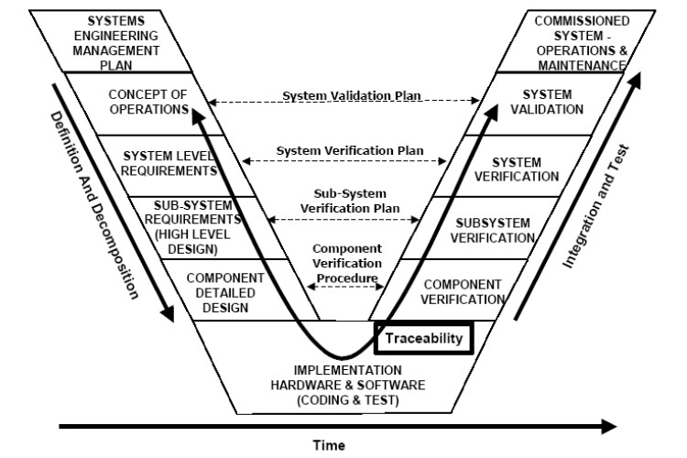
Fig. 1. Caption
- Equations
Equations and formulae should be typed in Mathtype, and numbered consecutively with Arabic numerals in parentheses on the right hand side of the equation (if equation is referred to explicitly in the body).
(1)
Acknowledgements
Acknowledgements and Reference heading should be left justified, bold, with the first letter capitalized but have no numbers. Text below continues as normal.

- An example appendix
Authors including an appendix section should do so before References section. Multiple appendices should all have headings in the style used above. They will automatically be ordered A, B, C etc.

  - Example of a sub-heading within an appendix
There is also the option to include a subheading within the Appendix if you wish.
References
1. Van der Geer J, Hanraads JAJ, Lupton RA. The art of writing a scientific article. J Sci Commun 2000;163:51-9.
2. Strunk Jr W, White EB. The elements of style. 3rd ed. New York: Macmillan; 1979.
3. Mettam GR, Adams LB. How to prepare an electronic version of your article. In: Jones BS, Smith RZ, editors. Introduction to the electronic age. New York: E-Publishing Inc; 1999. p. 281-304.

